La Misión Fundación
Short Term Volunteer Intern Program Application

Dear Volunteer,

Thank you for your interest in participating in La Mision, Guatemala’s Short-Term Volunteer Program!!

Please take some time to fill out the following application. This is a template designed to allow you to fill-in-the-blanks. If you need more space, continue typing and another line will appear. You can move from field to field using the [tab] key, or the arrow keys.

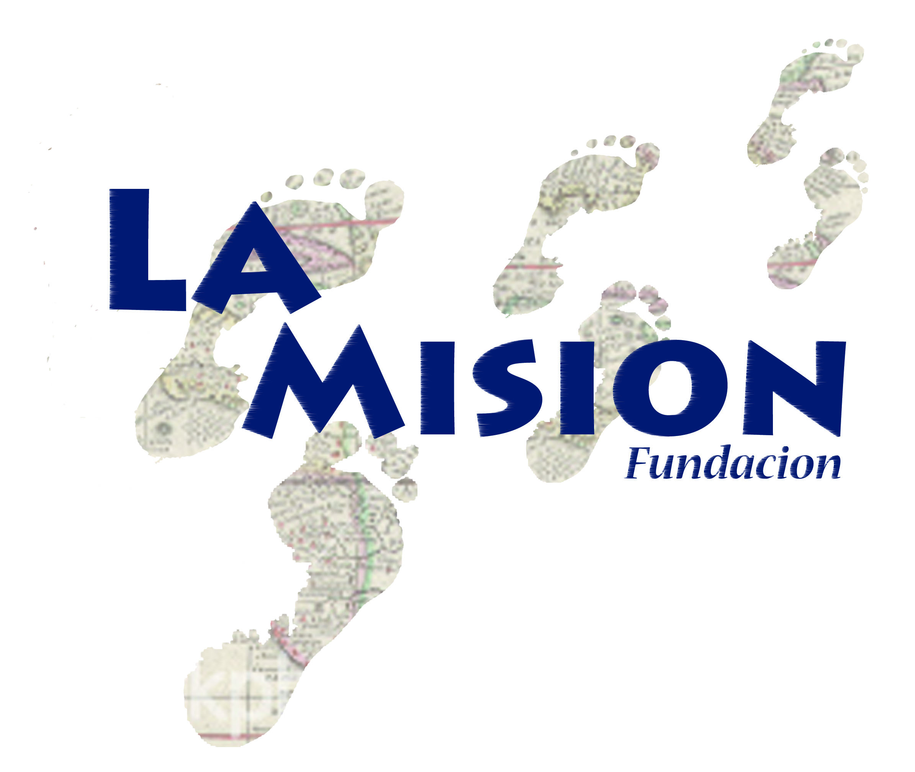
When you are asked to respond to a “Yes” or “No” question, you can use your cursor (place the cursor over the appropriate box and “click”), or you can use your keyboard (when you have used the [tab] key to move to the boxes, you will notice that the box becomes “bold” – press your spacebar to indicate the bold box is your choice). If you “check” a box in error, repeat these same steps to undo your choice, and make the correct choice.

Once you have completed the form, simply save it on your computer, and then send me a copy as an email attachment.

If you have any questions, or experience difficulty with this form, please feel free to contact me and I will do my best to assist you!

I look forward to seeing what God has in store for you!!

Blessings,

Dr. Pedro “Tito” Palacios
Fundación La Misión, Guatemala

Fundación La Misión

Short-Term Volunteer Intern Program Application
The information you provide in this application will help us get to know you before you arrive.
Please provide a recent photograph of yourself.

PERSONAL INFORMATION
Name:
Address:
City/State: | Zip Code:
Phone #: | Email:
Date of Birth: | Occupation/School Level:
Parent’s Names:
Sibling(s) Name(s)/Age(s):
Marital Status: Single Married Involved Divorced Widowed
Religion Affiliation: Evangelical Catholic Other:_________________________
What are your favorite activities (hobbies, talents, skills, interests, school activities/classes, etc.)?
Are you currently studying or have studied Spanish? Yes No
Please rate your abilities on a scale from 0 to 5 (0 equals no ability, 5 equals fluency):
Speaking/Conversational? | Reading/Writing?
What are your expectations for the trip?
What do you hope to contribute to the ministry?
What do you hope to learn while serving?
How do you hope to grow during and after your time in Guatemala?

FAITH EXPERIENCE
Please give a statement of your faith.
Describe any team involvement, leadership, or ministry work you have had with your church, at work, at school, or as a volunteer over the last several years.
Have you traveled internationally? What cross-cultural (or mission-oriented) experience have you had?
What relationship do you see between this short-term ministry opportunity and/or vocational goals?
In you opinion, what is the purpose of a short-term mission experience?
How have you grown spiritually in your life?
What are some things you have been learning about your relationship with God?
FAITH SELF EVALUATION:
1 = NEEDS WORK |  | 3 = AVERAGE |  | 5 = EXCEPTIONAL
Commitment to Christ |  | Listening Skills |  | Flexibility
Dependability |  | Patience |  | Cooperation
Organization |  | Communication Skills |  | Teamwork
Initiative |  | Appreciation of diversity |  | Sensitivity
Decisiveness |  | Confidence |  | Respect for authority

AREA OF INTEREST/EXPERIENCE
Please indicate the areas in which you have interest and/or experience.
Place an “I” for interest and “E” for experience. Both may apply.
Small Group Leader | Evangelism | Carpentry | Medical | Sports
Bible Study Leader | Prayer | Electrical | Dental | Musical Instruments
Worship Leader | Administration | Painting | Optical | Singing
Youth Leader | Accounting | Mechanics | Arts/Crafts | Other:
Teacher | Computers | Agriculture | Sewing
Youth/Kids Activities | Photography | Cooking | Drama/Puppetry

HEALTH/MEDICAL INFORMATION
It is strongly recommended that all participants have full medical insurance coverage during their stay in Guatemala. If you have not done so, please arrange for appropriate international services and treatment. Please provide La Misión with a list from your insurance carrier of approved hospitals in Guatemala, and remember to bring proof of insurance.
Have you verified that your insurance company can provide full International services and treatment while in Guatemala? Yes No
Do you have a physical condition/limitations that would prevent you from participating in ordinary activities? Yes No
If yes, please explain briefly.
Do you have any allergies (food, environmental, animals, etc.) which might be of concern during your stay in Guatemala? Yes No
If yes, please explain briefly.
Do you have any dietary concerns/preferences (lactose intolerant, vegetarian, gluten-free, etc.) which might be of concern during your stay in Guatemala? Yes No
If yes, please explain briefly.
Are you currently taking any medication (including herbal medications)? Yes No
If yes, please explain briefly.
Do you have any allergies to medications? Yes No
If yes, please explain briefly.
Are you currently, or have you in the past 4 years, sought professional help for health problems, depression, psychological or physical addictions, or high stress? Yes No
If yes, please explain below. If you prefer to discuss this in person, please let us know.

EMERGENCY CONTACT INFORMATION
PLEASE PROVIDE US WITH AT LEAST TWO EMERGENCY CONTACTS. Note: Our doctors are available at all times to help with minor injuries or illnesses. However, in case of emergency, we will need contact information.
Name: | Relationship:
Phone #: | Phone #:
Name: | Relationship:
Phone #: | Phone #:

PERSONAL REFERENCES
We would like to learn how other people see you. Please forward this form to at least two people (non-family members) that can provide honest and accurate information about you.
Guide Questions:
Please describe your relationship with the applicant.
How long have you known this applicant?
Have you worked with or been a part of a team/project with this applicant? How was that experience?
What are three strengths in this applicant? How would these be an asset to La Misión/a short term mission internship?
What are three weaknesses in this applicant? What are your recommendations of how should we addresses thees weaknesses during this short term mission internship?
How are you involved in supporting (prayer, financial, etc.) this applicant while he/she is in Guatemala?
Any other information we should know about this applicant that you feel is applicable to a short term mission internship?

APPLICANT AGREEMENT
In signing this document, I am declaring I have read the Short Term Volunteer Intern Orientation Packet and agree to abide by the rules and regulations established by La Misión. I also fully acknowledge and understand the financial obligations associated with my participation.
Short Term Volunteer Intern’s Signature: | Date:
Parent/Legal Guardian (if applicant is under 18 years of age): | Date:

